**DICE ROLL**

Screenshot of the initial screen of the Dice rolling Game.

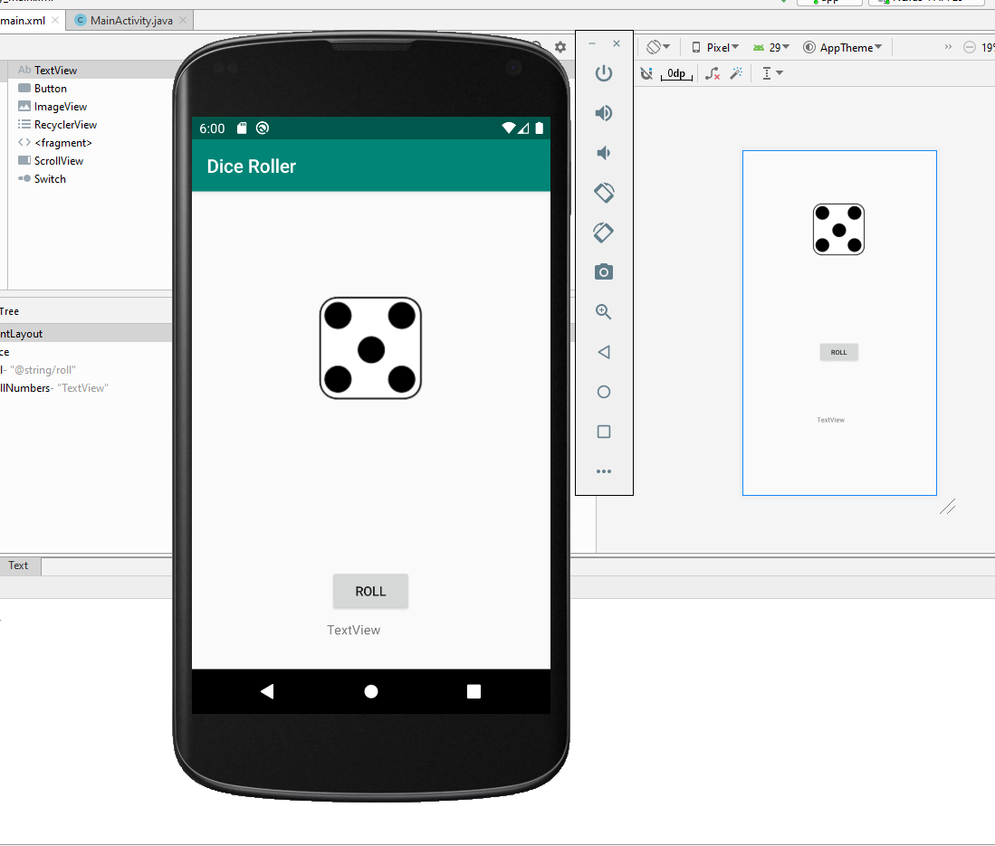

A screenshot after I rolled the Dice—and the outcome.

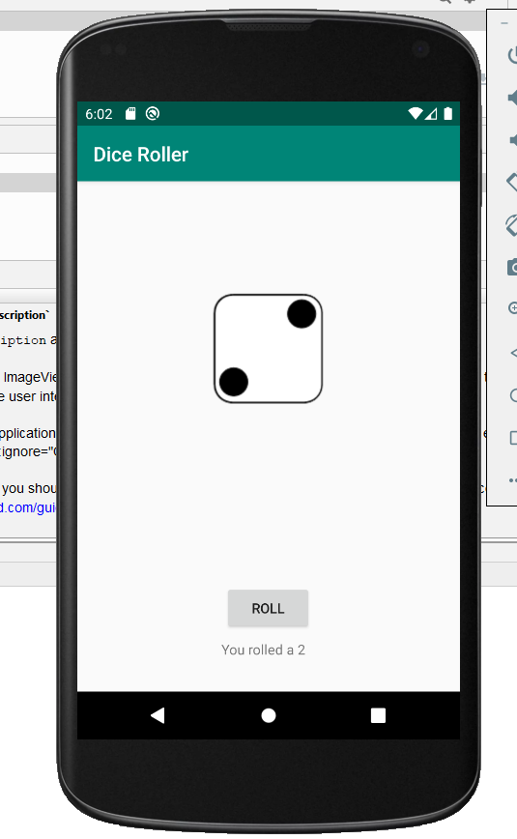

**Rock/Paper/Scissor**

Screenshot of the application

